**MINI PROJECT**

**(2020-2021)**

**SHARE-OPS**

**A file sharing application for Android**

**MID TERM REPORT**



**INSTITUTE OF ENGINEERING AND TECHNOLOGY**

**Submitted By – Supervised By -**

Abhishek Yadav (181500031) Neeraj Khanna

Kuldeep Kumar (181500339)

Arpan Khandelwal (181500129)

Achyut Kumar Tiwari (181500034)

Abhishek Singh (181500027)

**Contents**

|  |  |
| --- | --- |
| Abstract |  |
| **1. Introduction** |  |
| 1.1 General Introduction to the topic |  |
| 1.2 Area of Computer Science |  |
| 1.3 Hardware and Software Requirements |  |
| **2. Problem definition** |  |
| **3. Objectives** |  |
| **4. Implementation Details** |  |
| **5. Progress till Date & The Remaining work** |  |
| **6. Some Screenshots** |  |
| **7. References** |  |

**ACKNOWLEDGEMENT**

We have taken efforts in this project. However, it would not have been possible without the kind support and help of many individuals. On the completion of this project we would like to extend our sincere thanks to all of them. We are highly indebted to our project guide **Mr. Neeraj Khanna**.

We would also like to thank all those who directly or indirectly supported or helped us in completing our project in time.

We would lie to express our gratitude towards our parents and the members of our college for their kind cooperation and encouragement which helped us in completing this project. All of them have willingly helped us out with their abilities.

**Abstract**

In this project we are creating a file sharing application over Wi-Fi for android, we all know that the performance of mobile devices, especially smart phones, has been quickly improved for the last few years. Most users take advantage of highly efficient smart phones, and consume the contents in the smart phones longer time than other devices usage time. As a result, users frequently share the contents and the needs of file sharing via smart phones have been increased considerably.

A Web hard-based sharing needs to pay expensive cost for using high-volume file servers as well. In order to overcome such problems, we propose an application for seamless file sharing for the Android devices.

With majority of our population being offline and many with the unstable and not so very high-speed Internet, there must be a way or a tool so that at least they are able to share files between their own or with someone else’s devices seamlessly and without any hassle

As in the near future data will also become more and more important so eventually data sharing will also become part of our daily life.

As the technology keeps growing data sharing wirelessly will also become more and efficient and fast

Sharing data via wireless technology will be very efficient as people didn’t need to be worry about effect of external means, for instance consider the below scenarios -

* While using data transfer cables there is always a concern of interruption such as cable damage, unplugging of cable.
* While using data storage devices there is a threat of damaging the device.

**1.Introduction**

In this project, we are trying to build a fast file sharing system which include detection, data transmission. Our problem can be simply described as that when 2 mobile devices encounter with each other, one need to detect quickly whether the other one has the file it need and furthermore, we can divide files into chunks and use some algorithm to identify the existence of the chunks. However, in the real case, it could be multiple devices share the files at the same time.

**About Android**

Android is a relatively new mobile operating system developed by Google and the Open Handset Alliance. Officially released in October 2008, it has revolutionized mobile application development due to the fact that it is open source. It allows developers unparalleled freedoms to create varied and interesting applications. Based on the Java programming language, it is touted as being easy to pick up and master, whilst the underlying is a modified Linux kernel. Some of Android's biggest draws for developers include the relative simplicity of developing using Java syntax, which means quickly producing applications. Also, Android provides easy yet secure access to first and third party applications, allowing deeper integration between components in different programs, and encourages software sharing and reuse. The user interface can be built quickly and simply through XML or graphically, and once an application has been finished it can be submitted to Android market, a portal through which developers can make their creations available to Android users, either free or for profit.

Java is a general-purpose, concurrent, class-based, object-oriented computer programming language that is specifically designed to have as few implementation dependencies as possible. It is intended to let application developers "write once, run anywhere" (WORA), meaning that code that runs on one platform does not need to be recompiled to run on another. Java applications are typically compiled to bytecode (class file) that can run on any Java virtual machine (JVM) regardless of computer architecture. Java is, as of 2012, one of the most popular programming languages in use, particularly for client-server web applications, with a reported 10 million users. Java was originally developed by James Gosling at Sun Microsystems (which has since merged into Oracle Corporation) and released in 1995 as a core component of Sun Microsystems' Java platform. The language derives much of its syntax from C and C++, but it has fewer low-level facilities than either of them.

The **aim** of this project is to design and implement a file sharing application for Android based devices. This project will allow multiple users to share files to multiple devices. This project would provide a stable platform to enable collaboration through file sharing. To this end, files may be uploaded by one user and available to another, all simplified through an easy to use application on an Android device.

**Linux Kernel**

Android uses the Linux kernel. The “Linux” part is easy enough to understand, it is a play-on-words of Linus, as in Linus Torvalds, the original creator of Linux. But *kernel*? What is a kernel? What do we mean by the Linux kernel?

The thing to remember about computer is that they have no mind they cant think, their IQ is 0. They only know one thing and that thing is to execute instructions. One instruction after the other, round and round.

 It is only when a set of instructions is created that performs a useful task that computers, including mobile devices, take on a semblance of ability.

From the moment a computer starts it needs instructions, it can’t do anything without them. Even while your Android device is booting and showing some boot logo, the CPU is just following instructions. Once your phone is fully booted you get Android. What we see of Android is a nice launcher, some apps like the Chrome web browser and maybe some games. But there is more going on than meets the eye.

Under the user interface there are a bunch of different systems including the Java virtual machine (i.e. Dalvik or ART) and the Surface Flinger, which is responsible for compositing all the different things that needs to be drawn into a single buffer that is then displayed on the screen.

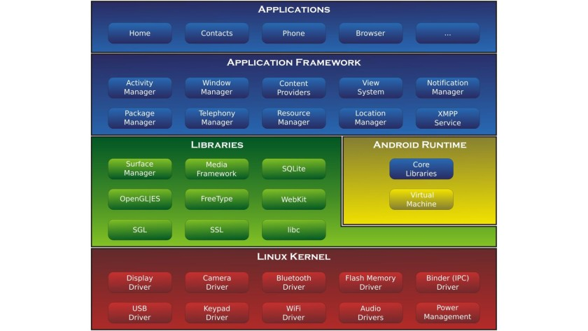

Go down deeper, really deep – beyond the permafrost, and you reach the kernel, the Linux kernel to be precise. All multi-tasking operating systems have a kernel of one form or another. Windows has a kernel, OS X has a kernel, iOS has a kernel, Windows Phone has a kernel, and of course Android has a kernel. But of those only Android uses the Linux kernel. Windows and Windows Phone/Mobile have their own kernel often referred to as the NT kernel, while OS X and iOS use a kernel known as Darwin.

kernels are important, but what are they? In a nutshell the kernel is the core program which manages the CPU resources, the system memory, the system devices, including the file systems and networking, and is responsible for managing all the processes.

That means that when you start an app it is the kernel which loads the app into memory, creates the processes needed and starts the app running. When app needs memory it is the kernel that allocates it. When the app wants networking it is the kernel which does all the low level processing. The driver for devices like Bluetooth are also in the kernel. When the app wants to perform a task in the background it is the kernel which handles the background threads. When the app closes it is the kernel which cleans up all the memory and other resources that were used by the app.

**Purpose and scope**

The application keeps the user files safe and secured. Application allows user to search a file in the search box. Maintains the files in a categorized and in a structural manner. It avoids the data duplication which prevents the re-writing of the similar file. In this application we maintain the data in an efficient manner and we have made our best efforts to make the UI as user friendly as possible.

**Why this project? and how will it help?**

With majority of our population being offline and many with the unstable and not so very high-speed Internet in India, there must be a way or a tool so that at least they are able to share files between their own or with someone else’s devices seamlessly and without any hassle.

**Hardware and software requirement for development**

|  |  |
| --- | --- |
| Hardware - | Ram of 4gb(minimum)  quadcore |
| Software - | Android Studio |

**Hardware and software requirement for use**

|  |  |
| --- | --- |
| Hardware - | Ram of 3gb (minimum)  Available size of 5gb |
| Software - | Android version of kitkat4.4.4 and above |

**2. Problem Statement**

Often in college or university and also in our working place, we need to share important files with others. Sharing video files, photos, eBooks, PDF, or DOC files become essential sometimes. But often, Wi-Fi connection or mobile data is not available around us so that we can share those files while being online.

We all know about the Internet connection in India, India boasts many of the world's top IT companies, tech entrepreneurs and digital start-ups. Yet, it's also home to nearly 900 million people who do not have access to the internet.

**3. Objective of the Project**

In our day-to-day life data is the most important thing. sharing of data helps to save our time and internet.

Data can be shared in many ways (using Internet, cables, USB, portable storage dive) but in many forms the user is also occupied but with the help of our project, data can be shared wirelessly without consuming internet and without much effort of user.

As our life becomes more and more progressive, we get less time to do work manually according to our objective people will be able to share data on the go either while travelling or while doing some work without any interruption.

**4. Implementation Details**

There four main part of the work. They are Peer search, Query, Protocol and Data transmission. We will find peers via Wi-Fi direct. The Wi-Fi direct has many limitations, like only in android 4.0 device, and all the devices need open all the time to wait for connection. Since it is convenient, we will use it to simplify the work, and we will focus on developing the protocols and algorithm. Before we search the peers, we need do some initialization work, such as read file list and set up data structure.

After detecting the peers we need, we can connect with them and establish socket communication. Then we need use some protocols to check the files needed and availability and the exact chunk needed and availability.

All this work will be done in the query process. Hash tables and Bloom filter will be used to detect whether an element is a member of a set. The last part is data transmission. After all the work set, we can transmit the data based on the requirement. Then the file status will be updated in the file list.

**6. Screenshots**

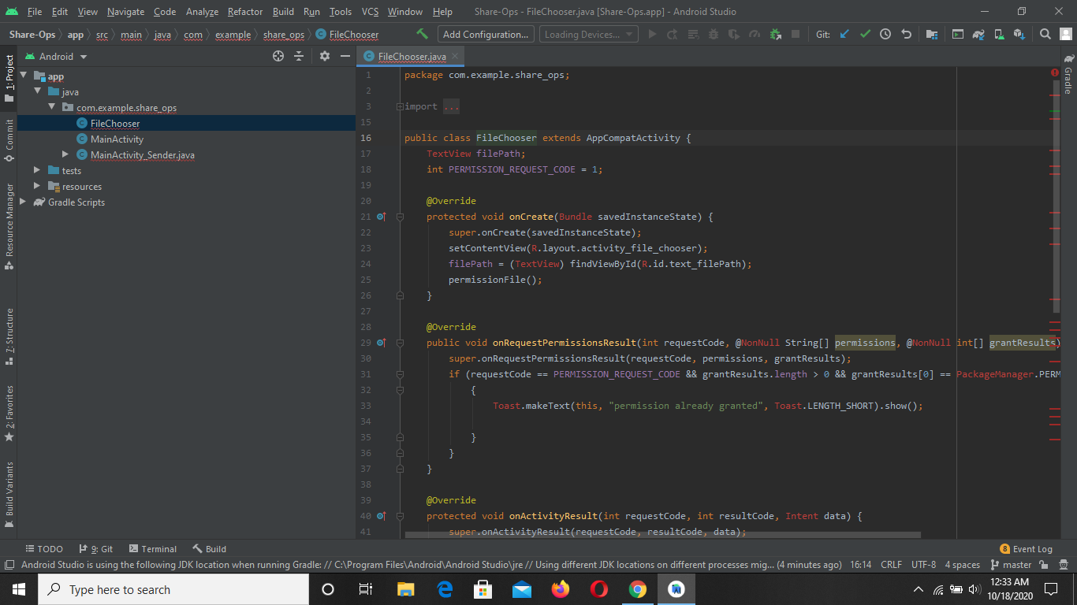

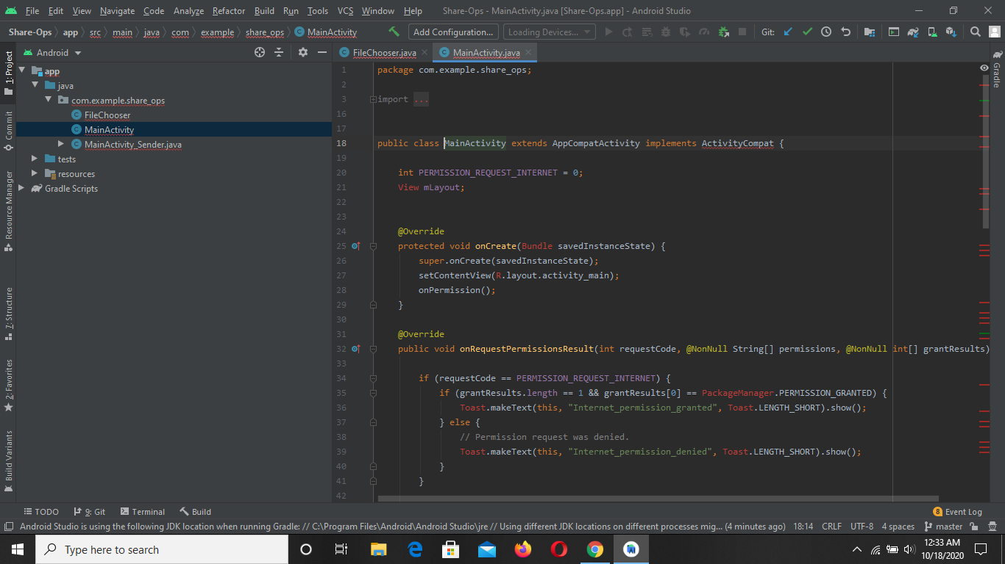

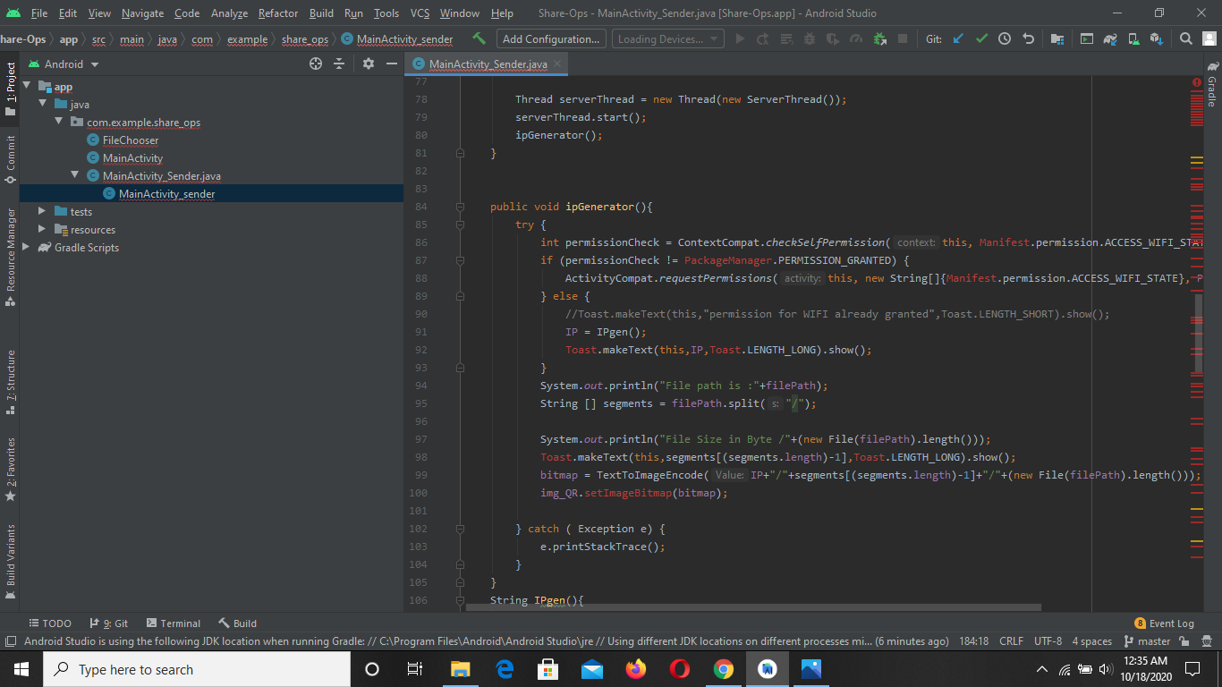

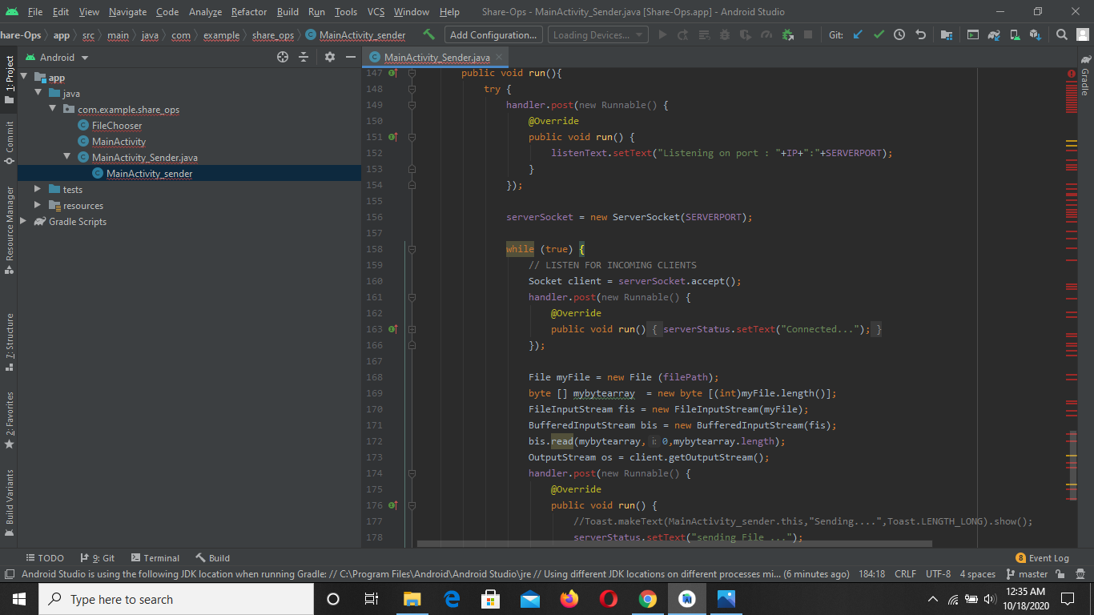

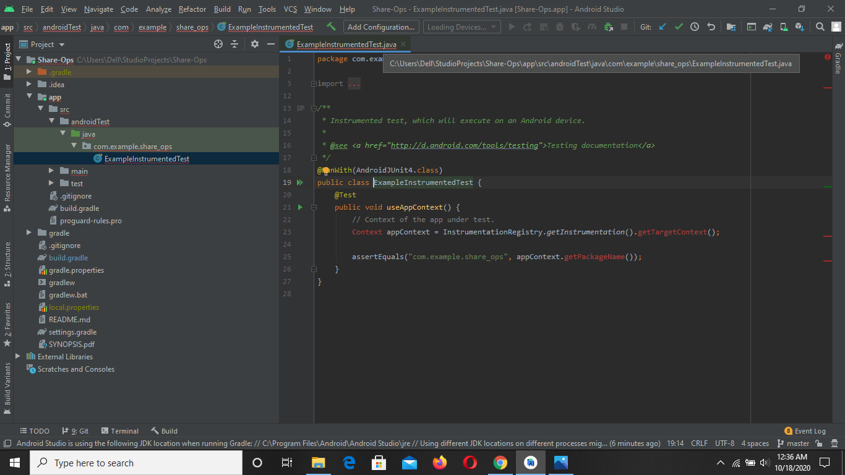

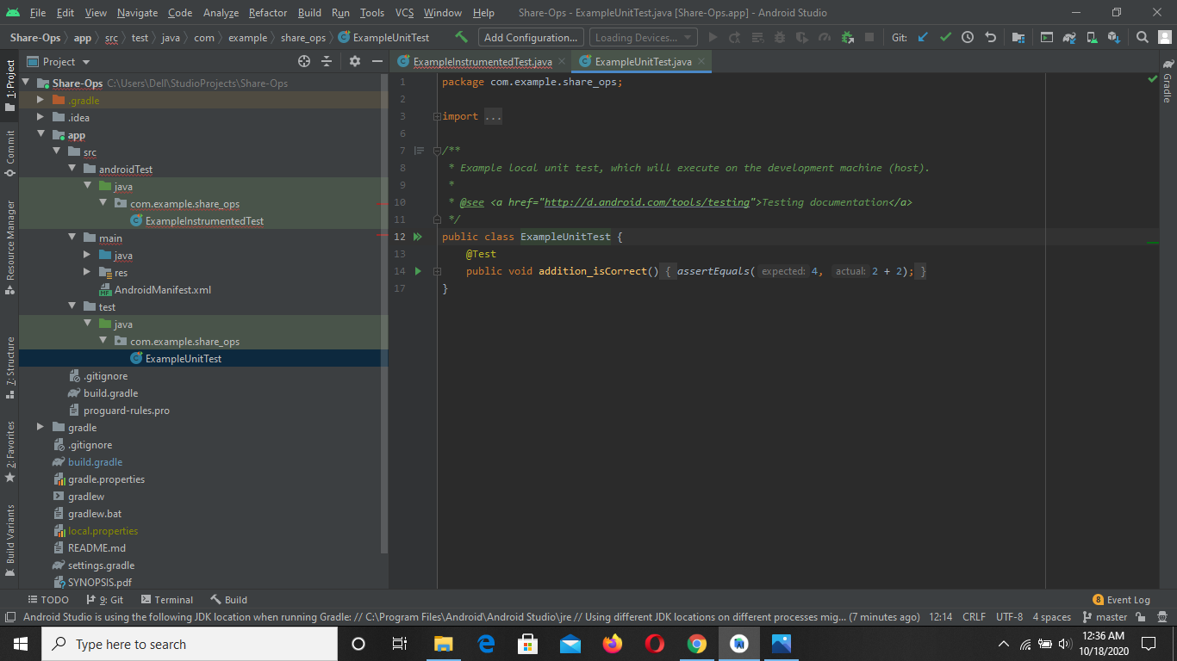

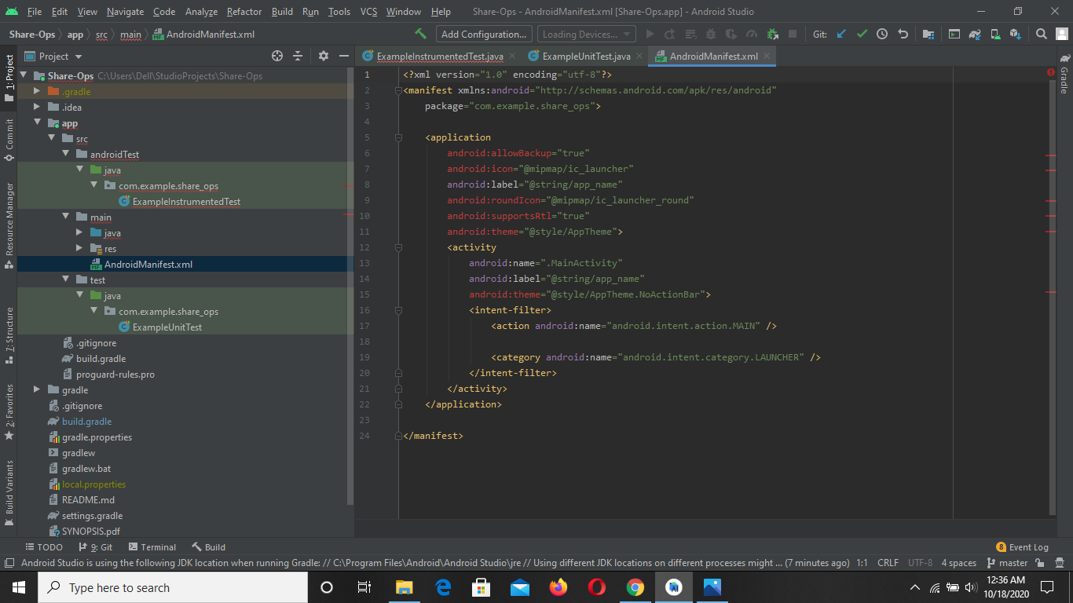

**Screenshots of the working APK**

the splash screen

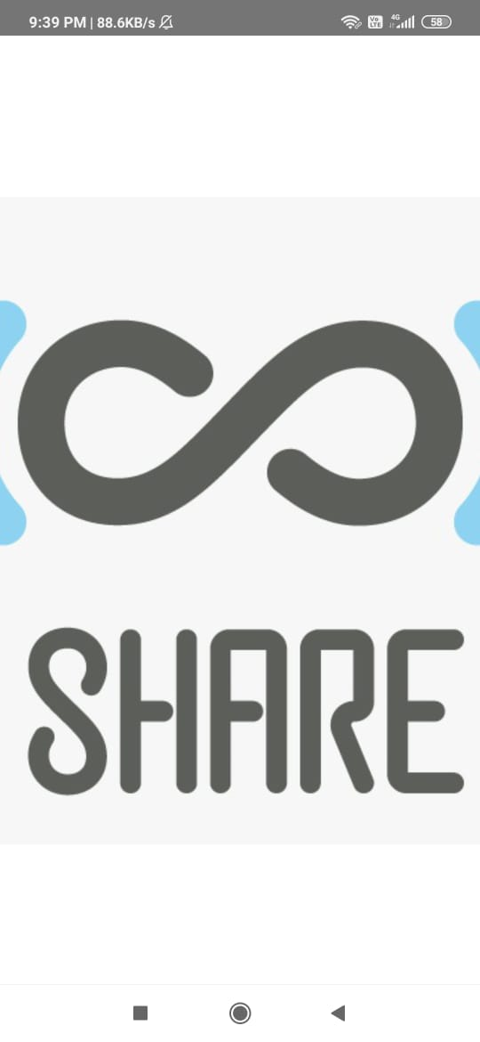

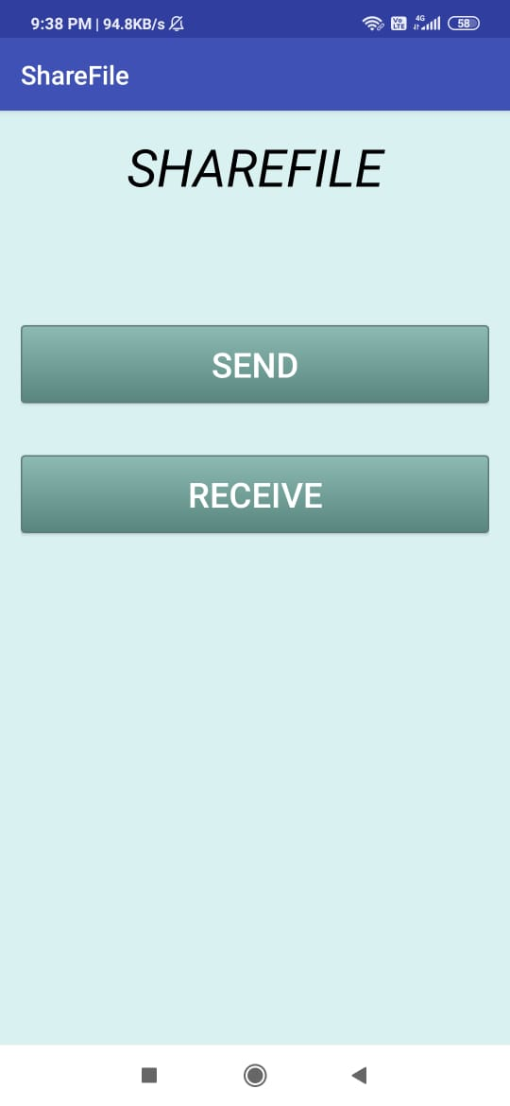

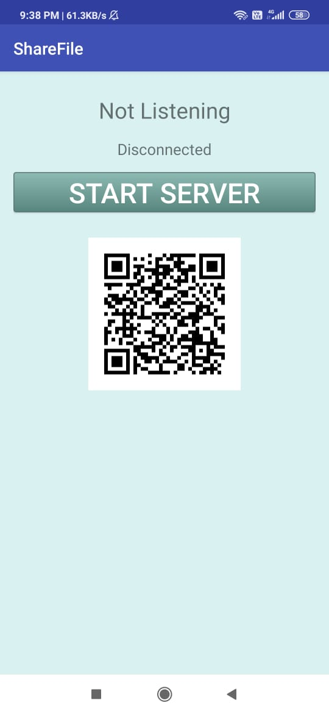

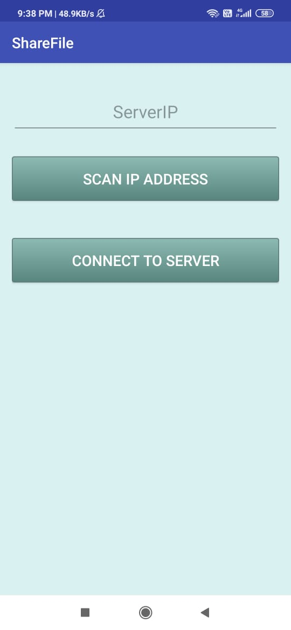

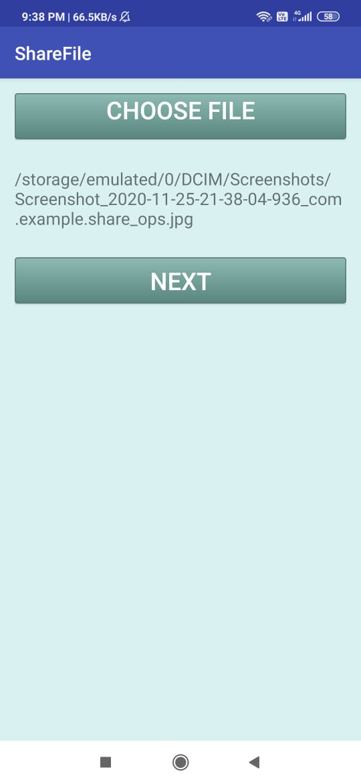

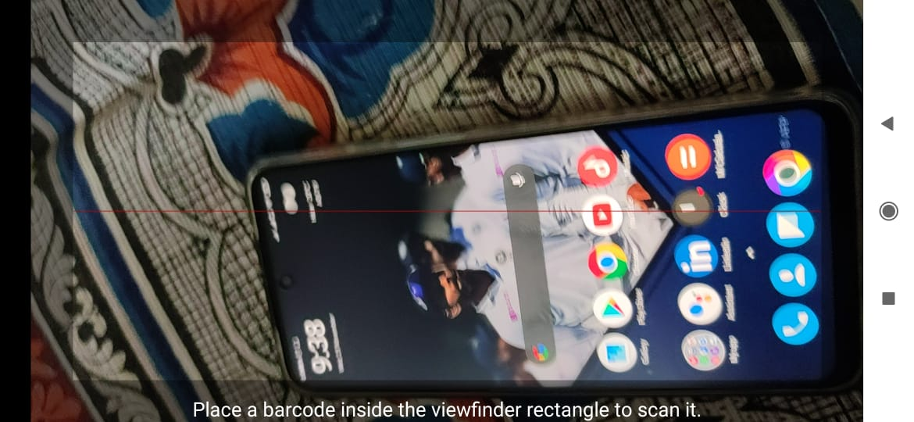

**7. References**

* Courses available on udemy

<https://www.udemy.com/course/androidappcourse/>

* Tips from android developer site

<https://developer.android.com/training/secure-file-sharing>